Here is a detailed overview / documentation of The Apollo University, Chittoor (AP-APollo University, Chittoor): its identity, courses offered, structure (schools), and a snapshot of its faculty / staff.

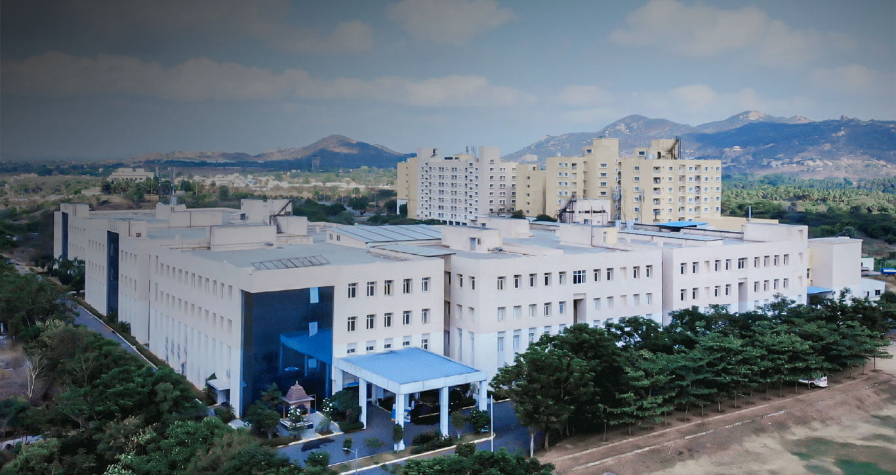

✅ Basic Info about Apollo University, Chittoor
- Apollo University is a state-private university in Andhra Pradesh, focused on professional education with a strong emphasis on healthcare, allied health, technology and management. (Apollo University)
- The campus is located at: Apollo Knowledge City Campus, Saketa, Murukambattu Post, Chittoor (AP), PIN 517127, India. (Apollo Hospitals)
- The University aims for “industry-ready” education with hands-on learning — including use of labs, hospital affiliations (since Apollo Group is primarily a healthcare group), simulation labs, practical internships, etc. (Apollo University)
- According to recent information, the faculty strength is substantial (e.g. one source lists “Faculty Count: 82”) across various schools. (vedantu.com)

🎯 Courses / Programs Offered
Apollo University has multiple Schools / Faculties and under them a range of UG (Undergraduate) and PG (Postgraduate) programmes. (Apollo Hospitals)
Schools
- School of Technology (Engineering / Computer Science / IT) (Apollo Hospitals)
- School of Health Sciences / Allied Health / Biomedical / Paramedical / Life Sciences (Apollo Hospitals)
- School of Management (Business / Healthcare Management) (Apollo Hospitals)
- School of Social Sciences (Social Work / related) (Apollo Hospitals)
Key Programs Offered
Here is a broad listing (not exhaustive) of courses offered under different categories as per recent data:
Degree Type | Course / Specialization
B.Tech / Engineering | Computer Science & Engineering (CSE) CSE — Artificial Intelligence & Data Science CSE — Software Engineering CSE — Cyber Security CSE / Computer Engineering (Cloud Computing) (Also other CSE-specializations listed) (Target Study)
B.Pharmacy | Bachelor of Pharmacy (B.Pharm) (Apollo University)
B.Sc / Allied Health / Biomedical / Life Sciences / Paramedical | B.Sc Physician Assistant B.Sc Medical Lab Technology B.Sc Imaging Technology B.Sc Anesthesiology & Operation Theatre Technology B.Sc Renal Dialysis Technology B.Sc Respiratory Technology B.Sc Emergency Medical Technology B.Sc Optometry Technology / Optometry B.Sc Biomedical Sciences B.Sc Genetics & Molecular Biology / Molecular Biology & Genetics B.Sc Health Psychology B.Sc Bio-Technology (Biotechnology) BPT (Bachelor of Physiotherapy) / other therapy/paramedical courses BSW (Bachelor of Social Work) / Social Sciences streams (Apollo Hospitals)
Postgraduate (M.Sc / M.Tech / MPH / MPT / MBA / MSW etc.) | M.Sc (various, e.g., Medical / Biomedical / Health-related / Life-sciences / Health Informatics & Analytics) M.Tech (Computer Science / Data Science / other engineering/IT specializations) Master of Public Health (MPH) Master of Physiotherapy (MPT) MBA — especially Hospital & Healthcare Management MSW (Master of Social Work) and other social-science / allied-health options (Collegedunia)
- According to the University’s own site: “Undergraduate, Postgraduate and Research” programmes are offered. (Apollo University)
- The design of programmes uses a CBCS (Choice Based Credit System) — allowing flexibility via core, elective, and skill-enhanced courses depending on programme. (Apollo University)
In short — Apollo University offers a wide/hybrid mix: engineering + IT, allied health/paramedical/biomedical, pharmacy, management, social sciences — a “multi-disciplinary” approach bridging technology + healthcare + management + social sciences.

👩‍🏫 Faculty & Academic Staff Overview
Apollo University lists a large number of faculty members across various departments and disciplines. (Apollo University)
Some notable / example faculty / staff:
- Prof. Dr. K. Bhaskar Reddy — Dean (one of the leaders). (Apollo University)
- Dr. Ramaiah Itumalla — Dean (I/C) (for School/Management) in certain areas. (Apollo Hospitals)
- Prof. A. Sethuramasubbiah — Professor, HOD & Centre of Excellence (CoE) (role in academics) (Apollo University)
- Dr. R. Satyanarayana — Professor & Program Coordinator (SOT / other) (Apollo University)
- Dr. Y. Sreeraman — Associate Professor (in one of the departments) (Apollo University)
- Several others: assistant professors, associate professors, lecturers across disciplines of technology, health sciences, management, pharmacy, etc. (Apollo University)
From external sources (student reviews, college-info pages), many faculty are described as PhD-qualified, “well-qualified and experienced”, with a mix of teaching + practical/industry exposure because of Apollo’s overall healthcare background. (Shiksha)
Also — in more specialized departments (life sciences, biochemistry, pharmaceutical sciences etc.), there are identified faculty such as Dr. Kavitha S (with 21 yrs of teaching experience in Biochemistry & Life Sciences) and Dr. G. Swapna (Assistant Professor, Dept. of Pharmaceutics, with research publications and patents) among others. (Apollo University)
In short — the faculty is large and diverse, covering engineering/IT, biomedical/health, pharmacy, management, social sciences etc., reflecting the multi-disciplinary nature of the university.

📄 Infrastructure, Campus & Learning Approach
From the official descriptions and documentation:
- Apollo University emphasizes hands-on learning — via well-equipped labs, simulation labs, practical sessions, hospital / clinical affiliations (since Apollo group is a major healthcare provider), aiming to make students “industry-ready”. (Apollo University)
- They support interdisciplinary learning, allowing cross-domain exposure (for example technology + health sciences + management + social sciences). (Apollo University)
- The academic structure uses CBCS (Choice Based Credit System), giving flexibility to students to pick electives/skill courses in addition to core courses. (Apollo University)
- Campus amenities often include hostel accommodation, labs, library, sports and recreation — supporting holistic development beyond academics. (Apollo University)

ℹ️ Additional Notes & Strengths
- Apollo University is part of the larger legacy of the Apollo Hospitals Group, which has long-standing credibility in Indian healthcare. This link potentially offers better hospital affiliations, clinical exposure, industry connections — especially beneficial for health/biomedical/paramedical/management courses. (Apollo University)
- The blend of engineering/IT + health sciences + management + social sciences makes it suitable for students who want interdisciplinary education or want to transition between streams (e.g. health + data science, or health management, etc.).
- The faculty appears to have a mix of experienced educators, PhD-qualified, with practical and research orientation (for example research publications, patents in pharmaceutical sciences). (Apollo University)

💡 What to Check / Confirm (When Considering Admission)
If you or someone reading this is thinking of joining Apollo University, it’s wise to check/confirm:
- The eligibility criteria for the specific course (e.g. 10+2 marks, entrance exam — for engineering B.Tech typically AP EAPCET is accepted) (vedantu.com)
- Course fee structure (varies widely depending on programme: B.Sc / B.Tech / B.Pharm / PG etc.) (CollegeDekho)
- Infrastructure and labs relevant to your course (especially for health/paramedical/biomedical, since practical/hands-on matters) — the University claims to provide well-equipped labs & hospital link. (Apollo University)
- Faculty in the department you are interested in — whether there are qualified and experienced faculty/researchers (since the faculty list is large, but relevance may vary by department)

✅ Summary
Apollo University, Chittoor is a relatively new but multi-disciplinary private university that brings together engineering/IT, health & allied health sciences, biomedical, pharmacy, management, social sciences under one roof. Its strong linkage to Apollo Hospitals gives it an edge especially for health / paramedical / hospital-management courses. The variety of courses and a large faculty make it a flexible option for students with diverse interests.
If you like — I can prepare for you a full-length “catalogue document” (in Microsoft Word / PDF style) listing all courses (UG + PG) + all faculty names + designations currently at Apollo (as per public data).
Do you want me to build that document for you now?

